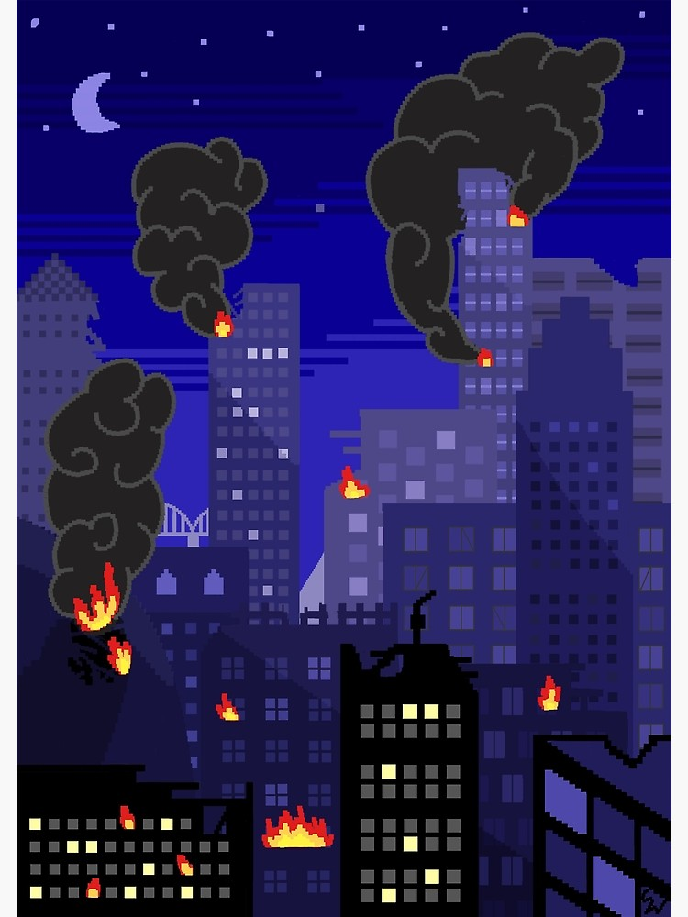

*KING OF TOKYO*

Table of Contents

Choosing your monster……….3

How to Play……….3

Rolling and Resolving Dice……….3

Attacking and Healing……….3

Victory Points……….3

Energy……….4

Tokyo……….4

Power Cards……….4

End of turn……….5

How to Win……….5

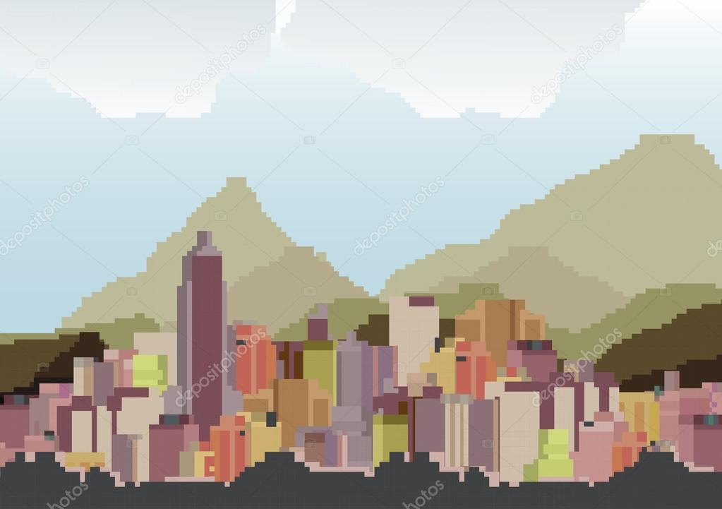

*Starting the Game*

Once you run the game on your computer and have the Start screen up, all you need to do is press the start button to begin a new game.

**Choosing your Monster**

Each player must choose their own monster to represent them in this epic battle.

Choose from the following Monsters:

Original: GREEN

Low Carb: BLUE

Absolute Zero: WHITE (zero calories)

Assault: RED

Mule: BROWN (Ginger brew)

Java: Tan (Coffee)

*How to Play*

Each player must roll the six dice and resolve them in order to determine what they can do with the rest of their turn. To decide who goes first, each player must roll the six dice and whoever rolls the most smashes, gets to go first.

**Rolling Dice**

Each player must roll the six dice at least once during their turn. If they are satisfied with the dice they rolled, they can resolve their dice right away or reroll their dice up to 2 times after the initial roll. After the third roll, the player must resolve their dice. After each roll, a player can pick dice they like to keep and reroll the rest to optimize their chances of being able to make a certain move during their turn.

**Resolve Dice**

During this stage of a player’s turn, they can attack other players, heal themselves, gain victory points, or earn energy points depending on their final set of dice.

**Attacking Other Players**

A player can only attack another player if they rolled at least one smash.

1 smash = 1 life point lost

**a monster can loses the same amount of life points as smashes being resolved

If the player is the first to resolve a smash in the game:

* They must enter Tokyo

If the player is not currently in Tokyo:

* They can only attack the monster can in Tokyo
* The monster can in Tokyo can decide to stay or yield Tokyo to the attacker
* In the case of a yield, the attacker can enters Tokyo

If the player is in Tokyo:

* All monster cans outside of Tokyo lose life points

When a monster can loses all their lives, they are eliminated from the game.

**Healing**

A player can gain life points when they resolve at least one heart.

1 heart = 1 life point

**BUT life points cannot exceed 10

If the player is in Tokyo

* They cannot gain any life points until they leave Tokyo

**Victory Points**

A player earns victory points when they resolve at least three of the same number.

For example,

3 + 3 + 3 = 3 victory points earned



And for every extra number resolved, the player earns an extra victory point.

For example,

3+3+3+3+3 = 3 + 2 = 5 victory points

**Victory points cannot exceed 20

**Energy**

A player receives energy when they resolve at least one lightning bolt.

1 lightning bolt = 1 energy gained

**Energy points can be used to buy power cards

*Tokyo*

Over the course of the game you will be presented with an opportunity to enter Tokyo. This comes with itself a plethora of both advantages and drawbacks, so choose carefully.

**Why do you want to be in Tokyo?**

The first advantage is that you automatically gain two victory points upon entering. Not only that, but every turn that you choose to remain inside of Tokyo, you will automatically earn another victory point. Alongside this, any claw that you roll while inside of Tokyo, will attack all other players in the game. So Tokyo is a great place to deal massive damage to other players and rack up some serious victory points.

**Entering Tokyo**

A player may enter Tokyo a number of different ways.

**Rolling the First Claw**

During every turn, the player will roll their own set of dice, once they have gone through resolving to the dice that they are happy with, you are presented with a final set of dice. If you are the first person to roll a claw, which is the dice face that allows you to attack other players, you will automatically be placed inside of Tokyo.

**Swapping yourself into Tokyo**

When attacking a player inside of Tokyo that player is given a choice. They may choose to stay inside and take the damage, or can swap you in their place. Placing you inside Tokyo, earning you two victory points, and leaving them safely outside of it.

**Why would you ever leave Tokyo?**

Well, with all of those advantages, there must be some drawbacks. The biggest one being that just as you can attack all players while inside, all players on the outside will be attacking you. So just as you are going after everyone else, all the other players will be pushing to get you out.

**How do you leave Tokyo?**

**Retreat**

When getting attacked inside of Tokyo you are given a choice. You may either stay inside and take the damage, or you can retreat. Putting yourself safely outside of Tokyo.

**Swapping yourself out of Tokyo**

As stated earlier, when getting attacked you have a choice to swap with the player attacking you as well. This will grant them two victory points keep in mind as well as all the benefits Tokyo brings with it. But it will also make them a target and place you out of harm's way.

**Buying Power Cards**

Three cards will be continuously placed face-up from the deck of power cards. One or more of these three cards can be purchased during your turn. If one of these cards fits your needs, you may purchase it by trading energy. Every power card displays the energy cost at the top card. If you have enough energy to purchase the desired power card, you may trade for the card and a new card is immediately placed face-up. As long as you have enough energy, you can continue to buy power cards.

**Sweeping Power Cards**

You can also spend two energy to sweep all three face-up cards to the discard. If you choose to sweep, three new power cards are placed face-up. These new power cards are available to purchase immediately after sweep. As long as you have enough energy, you can continue to sweep power cards.

**End of turn**

Once all power cards have been put into effect, pass the dice to the player on the left.

**So how do you win?**

There are many paths to becoming the King of Tokyo, so choose wisely and be sure to strategize.

**Getting to 20 victory points**

Whoever is the first player to reach 20 victory points is the winner. Regardless of current life points.

**Reduce all other Monsters life to 0**

If you are the last monster standing you are automatically declared the winner and King of Tokyo. Regardless of your current victory points.